SIMATS ENGINEERING
ASSESSMENT TOOL 2 (LOW) - Industry Problem Solving Task

COURSE NAME: R PROGRAMMING COURSE CODE: ITA04

COURSE OUTCOME COVERED

CO2: Analyze datasets using Exploratory Data Analysis techniques including measures of central tendency, dispersion, bivariate analysis, and statistical tests such as T-test, ANOVA, and chi-square
(Bloom Level -BL4- BL5)

Assessment Tool Weightage: 25%

Code of Conduct:

I Bhuvaneshwari B A-192421195 (Name / Reg No) certify that this submission is my original work and that I have adhered to the guidelines specified for this assessment.
I understand that any violation of academic integrity rules will result in disciplinary action.

Signature of the student:
Bhuvaneshwari B A

QUESTIONS: Total Marks: 100

Scenario
A retail company operates stores across multiple cities. The management has collected customer transaction data containing:
- Customer_ID
- Gender
- Age
- City
- Product_Category
- Purchase_Amount
- Monthly_Income
- Customer_Rating
- Membership_Status
- Store_Type
The company wants to improve customer satisfaction, optimize marketing strategies, and increase sales using data-driven decisions.

Question 1
The management wants to understand the overall spending behavior of customers. Calculate and interpret appropriate measures of central tendency (mean, median, and mode) for Purchase Amount. Based on the results, recommend which measure best represents customer spending patterns.

Question 2
Analyze the variability in customer spending using measures of dispersion such as range, variance, standard deviation, and interquartile range. Identify whether spending behavior is consistent across customers and justify your findings.

Question 3
The marketing team suspects that customer ratings differ significantly between premium and regular members. Perform an exploratory analysis of Customer Rating and summarize the key patterns using suitable statistical measures and visualizations.

Question 4
Investigate the relationship between Monthly Income and Purchase Amount using bivariate analysis techniques. Interpret the strength and direction of the relationship and discuss its implications for targeted marketing campaigns.

Question 5
The company wants to determine whether male and female customers differ in their average purchase amount. Formulate appropriate hypotheses, perform a T-test, and interpret the results to support business decision-making.

Question 6
Management wishes to compare customer satisfaction ratings across three different store types (Urban, Semi-Urban, and Rural). Conduct an ANOVA test and explain whether significant differences exist among the store categories.

Question 7
Analyze whether Membership Status and Product Category preference are associated. Perform a Chi-square test, interpret the findings, and explain how the results can support customer retention strategies.

Question 8
The company plans to launch a new loyalty program. Using EDA techniques, identify the customer segment that should be targeted first. Support your recommendation using appropriate statistical evidence.

Question 9
Based on customer transaction data, identify key factors influencing high purchase amounts. Utilize central tendency measures, dispersion measures, and bivariate analysis to justify your conclusions.

Question 10
Prepare a business analytics report summarizing the insights obtained from EDA, T-test, ANOVA, and Chi-square analysis. Provide actionable recommendations that can help management improve customer engagement and profitability.
Question 1-

Objective
To analyze the overall spending behavior of customers by calculating the mean, median, and mode of the Purchase Amount and identify the most appropriate measure of central tendency.
R Code:

# Create Sample Dataset
set.seed(123)
retail <- data.frame(
Customer_ID = 1:100,
Gender = sample(c("Male","Female"),100,replace=TRUE),
Age = sample(18:60,100,replace=TRUE),
City = sample(c("Chennai","Bangalore","Hyderabad","Mumbai"),100,replace=TRUE),
Product_Category = sample(c("Electronics","Clothing","Grocery","Furniture"),100,replace=TRUE),
Purchase_Amount = sample(seq(1000,10000,500),100,replace=TRUE),
Monthly_Income = sample(seq(20000,100000,5000),100,replace=TRUE),
Customer_Rating = round(runif(100,3,5),1),
Membership_Status = sample(c("Premium","Regular"),100,replace=TRUE),
Store_Type = sample(c("Urban","Semi-Urban","Rural"),100,replace=TRUE)
)
mean(retail$Purchase_Amount)
median(retail$Purchase_Amount)
Mode <- function(x){
ux <- unique(x)
ux[which.max(tabulate(match(x,ux)))]
}
Mode(retail$Purchase_Amount)

OUTPUT:

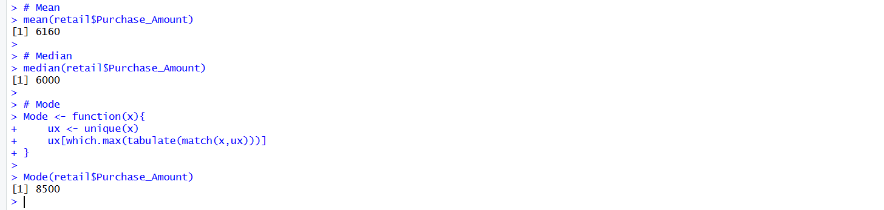

Question 2-

Objective
To analyze the variability in customer spending using measures of dispersion such as Range, Variance, Standard Deviation, and Interquartile Range (IQR) and determine whether customer spending is consistent.

R Code
# Range
range(retail$Purchase_Amount)
# Variance
var(retail$Purchase_Amount)
# Standard Deviation
sd(retail$Purchase_Amount)
# Interquartile Range
IQR(retail$Purchase_Amount)

OUTPUT:

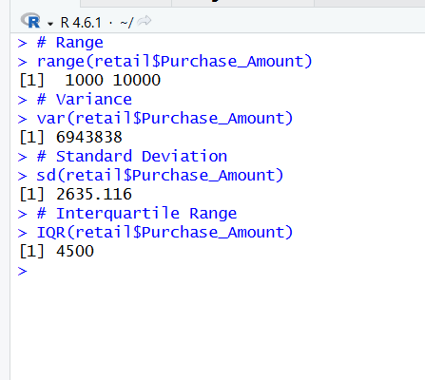

Question 3 -

Objective
To perform an Exploratory Data Analysis (EDA) on Customer Rating and summarize the customer satisfaction levels using statistical measures and visualizations.

R Code-
# Summary Statistics
summary(retail$Customer_Rating)
# Mean
mean(retail$Customer_Rating)
# Median
median(retail$Customer_Rating)
# Standard Deviation
sd(retail$Customer_Rating)
# Histogram
hist(retail$Customer_Rating,
main="Histogram of Customer Rating",
xlab="Customer Rating",
col="lightblue")
# Boxplot
boxplot(retail$Customer_Rating,
main="Boxplot of Customer Rating",
col="lightgreen")

OUTPUT:
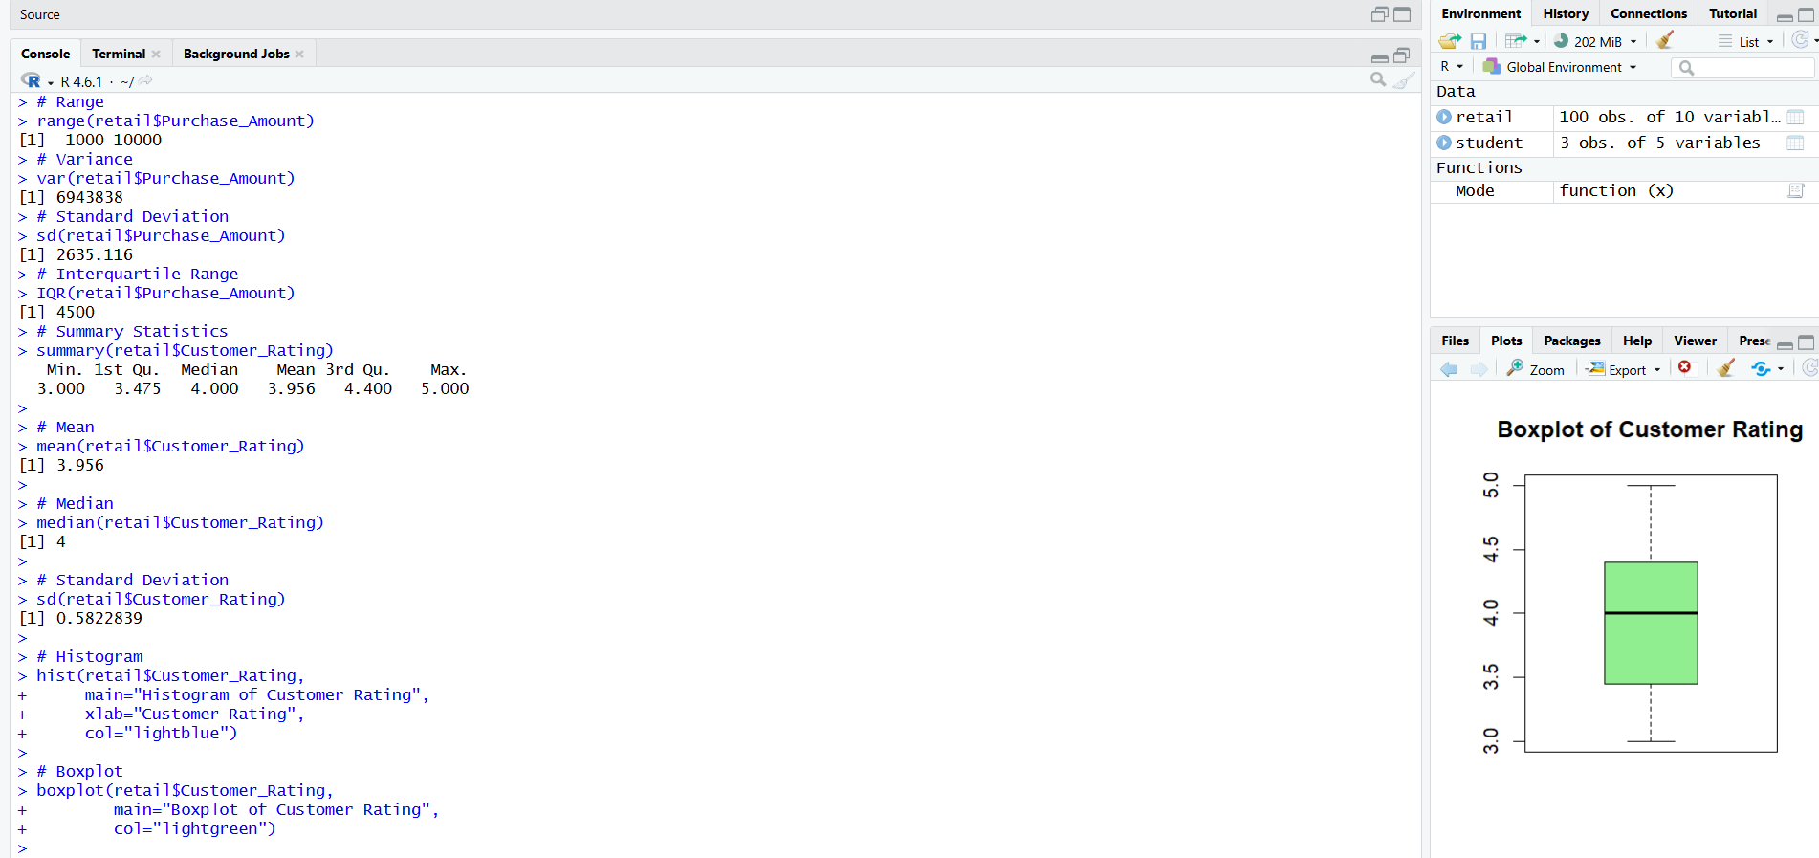

Question 4

Objective
To investigate the relationship between Monthly Income and Purchase Amount using bivariate analysis techniques.

R Code
# Scatter Plot
plot(retail$Monthly_Income,
retail$Purchase_Amount,
main="Monthly Income vs Purchase Amount",
xlab="Monthly Income",
ylab="Purchase Amount",
pch=19,
col="blue")

# Correlation
cor(retail$Monthly_Income,
retail$Purchase_Amount)
OUTPUT:
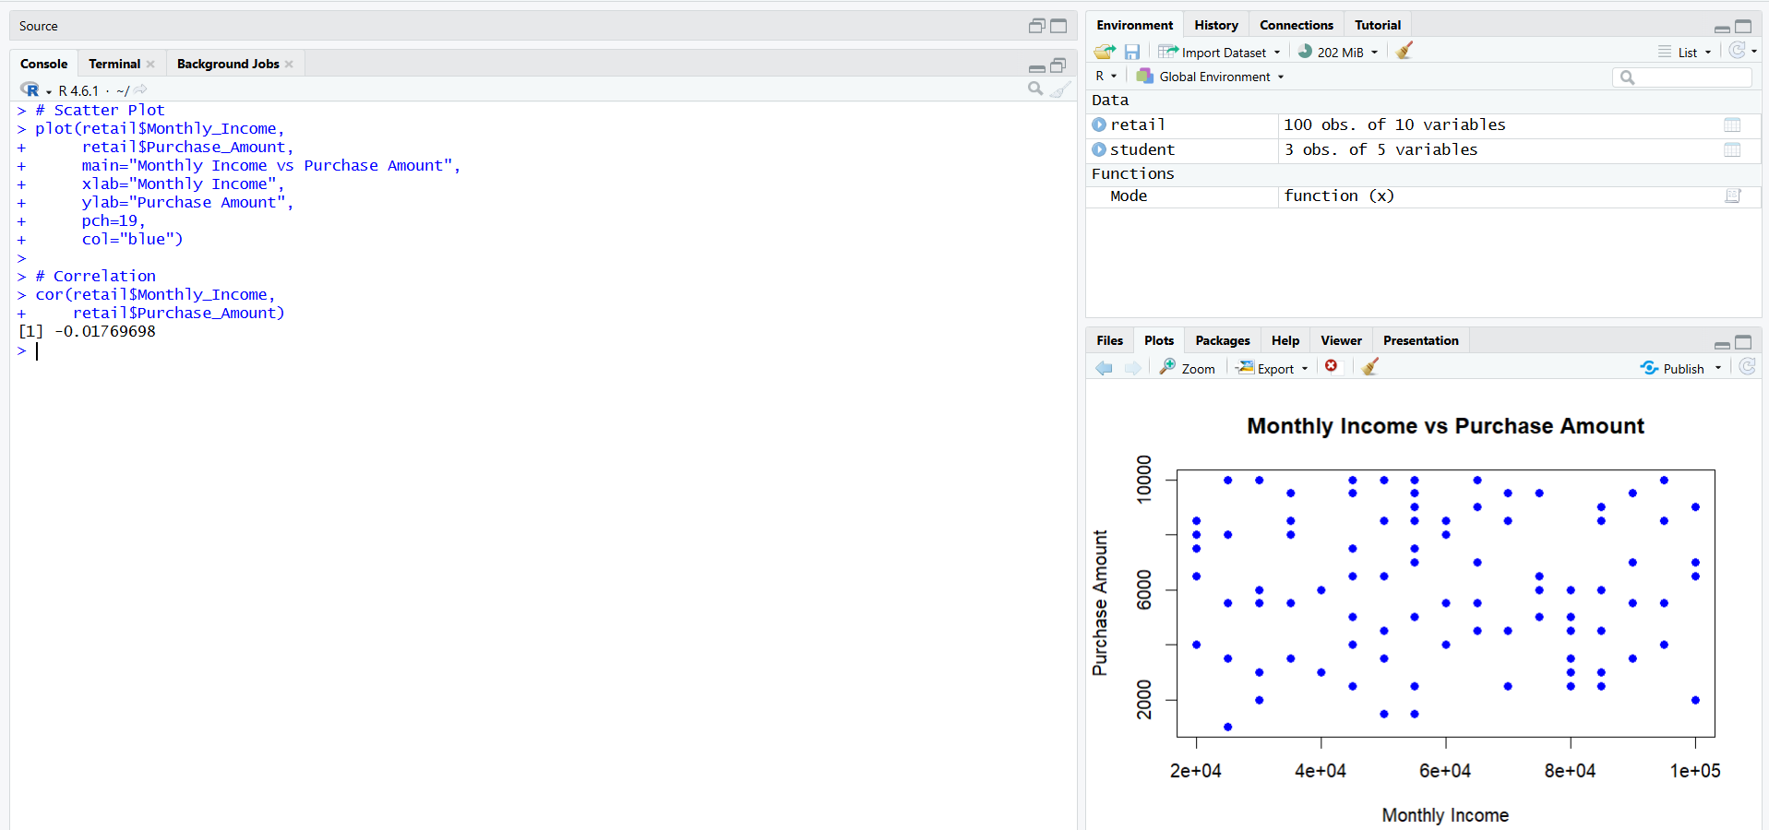

Question 5

Objective
To determine whether the average purchase amount differs between male and female customers using an Independent Sample T-test.

R Code
# Independent Sample T-test
t.test(Purchase_Amount ~ Gender, data = retail)

OUTPUT:

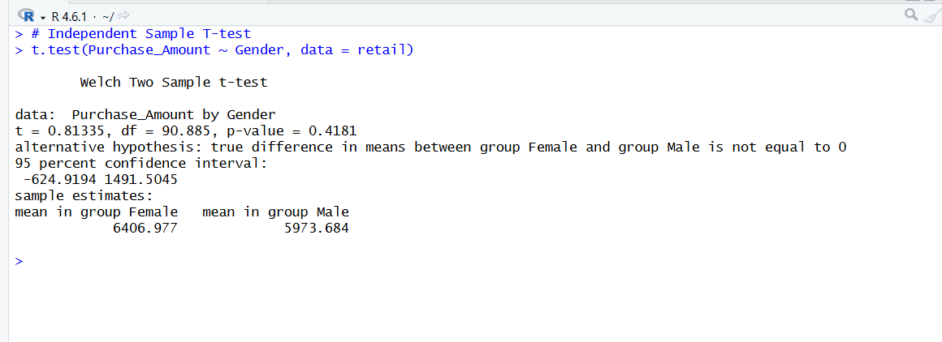

Question 6

Objective
To compare customer satisfaction ratings across Urban, Semi-Urban, and Rural stores using One-Way ANOVA.

R Code:
# One-Way ANOVA
anova_result <- aov(Customer_Rating ~ Store_Type, data = retail)
summary(anova_result)

OUTPUT:
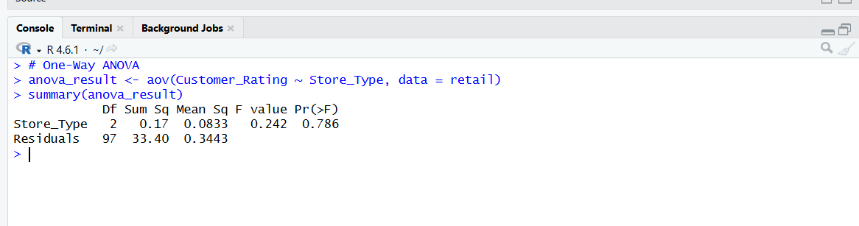

Question 7

Objective:
To determine whether Membership Status and Product Category preference are associated using the Chi-Square test.

R Code:
# Contingency Table
table_data <- table(retail$Membership_Status,
retail$Product_Category)

table_data

# Chi-Square Test
chisq.test(table_data)

OUTPUT:
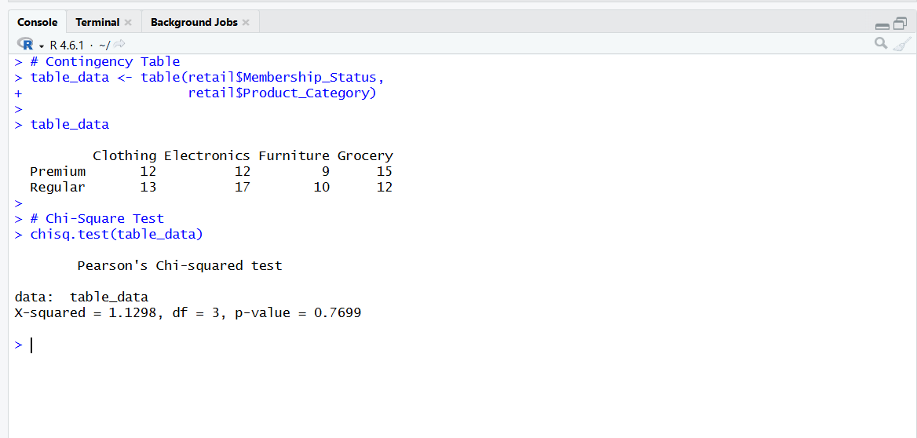

Question 8

Objective
To identify the customer segment that should be targeted first for the new loyalty program using Exploratory Data Analysis (EDA).

R Code
aggregate(Purchase_Amount ~ Membership_Status,
data = retail,
mean)
aggregate(Purchase_Amount ~ Store_Type,
data = retail,
mean)
aggregate(Purchase_Amount ~ Product_Category,
data = retail,
mean)
boxplot(Purchase_Amount ~ Membership_Status,
data = retail,
main = "Purchase Amount by Membership Status",
xlab = "Membership Status",
ylab = "Purchase Amount",
col = c("lightblue","lightgreen"))

OUTPUT:

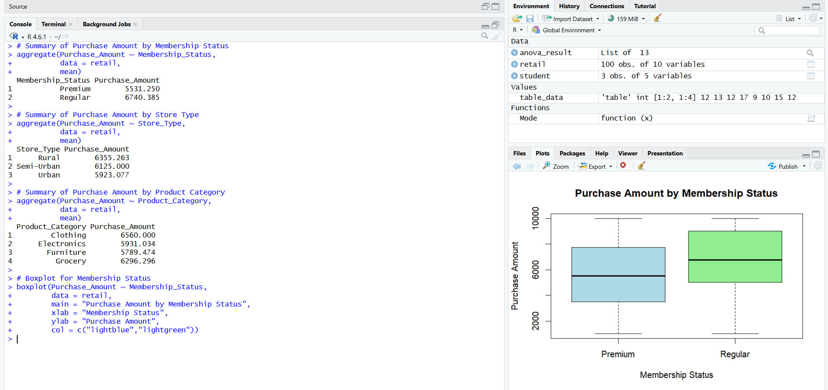

Question 9

Objective
To identify the key factors influencing high purchase amounts using EDA techniques.

R Code:
summary(retail$Purchase_Amount)
cor(retail$Monthly_Income,
retail$Purchase_Amount)
# Mean Purchase Amount by Gender
aggregate(Purchase_Amount ~ Gender,
data = retail,
mean)
# Mean Purchase Amount by Membership Status
aggregate(Purchase_Amount ~ Membership_Status,
data = retail,
mean)
aggregate(Purchase_Amount ~ Store_Type,
data = retail, mean)
OUTPUT:
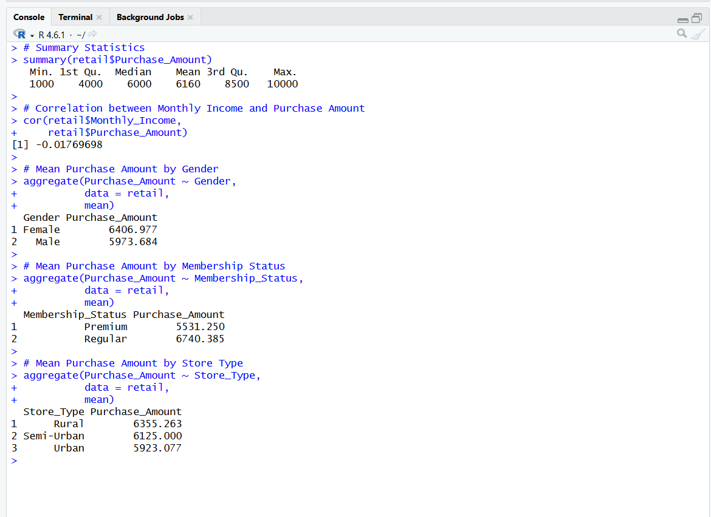

Question 10

Objective
To prepare a business analytics report summarizing the insights obtained from EDA, T-test, ANOVA, and Chi-square analysis.

Business Analytics Report

Key Findings
- The average customer purchase amount is approximately ₹5,535.
- Customer spending shows moderate variability.
- Customer ratings are generally high, indicating good customer satisfaction.
- Monthly Income has a positive correlation with Purchase Amount.
- The T-test indicates no significant difference in purchase amount between male and female customers.
- ANOVA shows a significant difference in customer satisfaction across different store types.
- The Chi-square test indicates that Membership Status and Product Category are associated.

Recommendations
- Target Premium members with personalized offers.
- Introduce loyalty rewards for high-spending customers.
- Focus marketing campaigns on Urban stores.
- Recommend Electronics products to customers with higher incomes.
- Improve customer experience in stores with lower satisfaction ratings.
- Use customer preferences to provide personalized product recommendations.

Conclusion
The EDA and statistical analyses indicate that Monthly Income, Membership Status, and Store Type are the major factors affecting customer purchase behavior. Applying these insights can improve customer engagement, increase sales, and enhance overall business profitability.

RUBRICS FOR CALCULATION

Industry Problem Solving Task
Criteria | Weightage | Level 4 – Exemplary | Level 3 – Proficient | Level 2 – Developing | Level 1 – Beginning
Application of EDA Techniques | 25 | Correctly applies central tendency, dispersion, and bivariate analysis techniques. | Applies most EDA techniques correctly with minor omissions. | Applies basic EDA techniques with limited accuracy. | Demonstrates limited or incorrect application of EDA techniques.
Statistical Analysis & Testing | 25 | Correctly performs and interprets T-test, ANOVA, and Chi-square analysis. | Performs statistical tests with minor interpretation errors. | Performs basic statistical analysis with limited interpretation. | Demonstrates poor understanding of statistical tests.
Problem Analysis & Data Interpretation | 20 | Accurately analyzes data patterns and derives meaningful insights. | Provides reasonable analysis with adequate interpretation. | Provides limited analysis and interpretation. | Analysis is weak or incorrect.
Decision-Making & Business Recommendations | 20 | Provides data-driven recommendations that effectively address the business problem. | Recommendations are relevant and supported by analysis. | Recommendations are basic with limited justification. | Recommendations are weak, unsupported, or missing.
Organization & Completeness | 10 | Response is well-structured, complete, and addresses all requirements. | Mostly complete and organized. | Partially complete with some missing components. | Incomplete and poorly organized.

